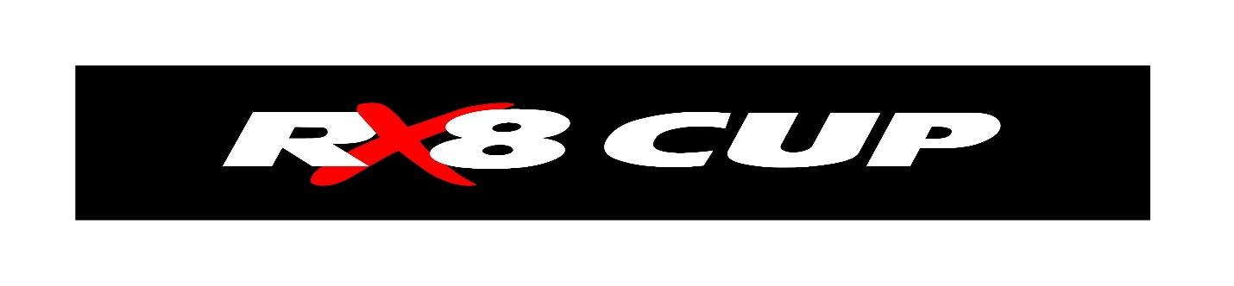
RX8 Cup 2021 Registration Application

Registrations must be paid for all RX8 Cup vehicles to compete in the 2021 championship.

RX8 Cup Series P/L
35 Parramatta Rd Five Dock NSW 2046
0418 649 320

Competitor Details
Name
Address
Phone
Email
Date of Birth
Driver CAMS Lic #
Licence Expiry Date
Log Book #
Dorian #
ARDC Member #
ARDC Expiry Date
Next of Kin Name
Next of Kin Contact #
Entrant Name
Entrant #
Car #
Car Colour

Registration fee for 2021 is $200.00.

Please make your payment via EFT to RX8 Cup Series Pty Ltd.
Bank Details Westpac BSB 032376 Account 366656.

Please return form to rx8cup@bigpond.com

By payment of registration competitors agree to abide by the RX8 cup series Rules and Regulations.

